**LINUX COMMANDS**

man – opens manual for commands

ls – list the contents of the directory

there are many types of ls

cd- change current directory

mkdir- create new directory

rm- deletes a file or folder

copy- copy one file content to another file

mv- moves a file from one location to another location

rename- renames a file

ping- checks if another computer is connected to the network

ifconfig- shows network configuration information

help- provides help for other commands

clear- cleans the terminal screen

date- Shows the current date and time

time - You want to see how long a command takes to execute

mkdir -p - Creates a directory and any missing parent directories

cat - Displays the contents of a text file

echo - Prints text to the terminal window

sudo - Grants temporary superuser privileges to execute a command

history – shows all the command previously executed

Write a command using ls to list all files (including hidden files) in the current directory and its subdirectories.

Ls –laR

Modify the previous command to display only files with a specific extension (e.g., .txt).

find . -type f -name "*.txt"

Enhance the report by including the file size for each listed file.

find . -type f -name "*.txt" -exec ls -lh {} \;

Further refine the output to display only files modified within the last 24 hours.

find . –type f –mtime -1

Combine the functionalities from points 2 and 4 to list only files with a specific extension (e.g., .jpg) modified in the last day.

find . –type f -name “*.jpg” –mtime -1

Use dir / ls to list all files and folders in your current directory. How many files are there? (Excluding hidden files if applicable)

Ls

ls -l | grep -v '^d' | wc –l



Utilize dir / ls with appropriate flags to display only files with a specific extension (e.g., .txt). How many files of that type exist?

ls *.txt

ls *.txt | wc -l

Navigate to your Downloads folder using cd. Then, use dir / ls to list the contents. Are there any recently downloaded files (modified today)?

Cd Downloads

Ls –lt

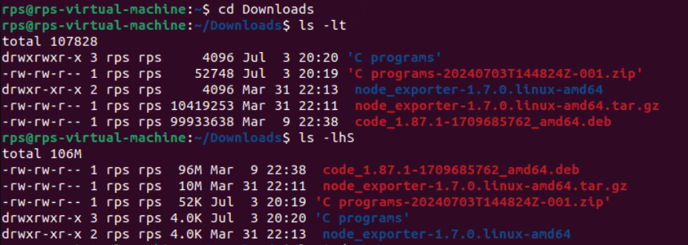

Use dir / ls with flags to display both the filename and its size for each file in your current directory. Identify the largest file.

ls -lhS

Practice using dir / ls with wildcards (e.g., dir *.docx) to list all files with a specific extension pattern (e.g., all Word documents).

ls *.docx

Use cd to navigate to your Documents folder. What is the full path of your Documents folder displayed by the prompt?

cd Documents

pwd

Practice using cd .. to move back one directory level from your current location.

cd ..

Utilize pwd to display the full path of the current directory after navigating with cd.

/home/rps/Documents

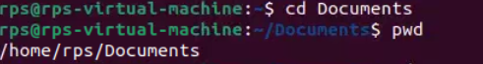

Explore using directory shortcuts (e.g., ~ for home directory) with cd to quickly reach specific locations.

cd ~/Documents

Combine cd with dir / ls to navigate to a specific folder and then list its contents.

cd ~/Documents

ls

Identify a file on your Desktop. Use cp to copy that file to your Documents folder. Verify the copy exists in Documents.

cp ~/Desktop/filename.txt ~/Documents/

ls ~/Documents/

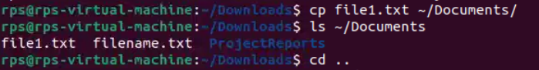

Practice renaming a file on your Desktop using mv. Give it a new name and confirm the change using dir / ls.

mv ~/Desktop/oldname.txt ~/Desktop/newname.txt

ls ~/Desktop

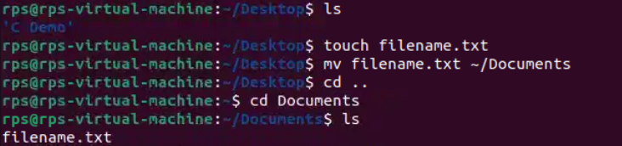

Locate a folder containing images. Use cp to copy a specific image file from that folder to another folder.

cp ~/Images/image.jpg ~/Pictures/

Explore using mv to move a folder containing documents to a different location within your file system.

mv ~/Documents/OldFolder ~/NewLocation/

Try copying a file that already exists in the destination folder. What happens? (Experiment with different flags for cp if applicable on your system)

cp -i ~/Desktop/file.txt ~/Documents/



Create a new folder named "Project Reports" inside your Documents folder using mkdir. Verify its existence using dir / ls.

mkdir ~/Documents/ProjectReports

ls ~/Documents



Practice using mkdir with multiple arguments to create a nested folder structure (e.g., mkdir Documents/ProjectX/Reports).

mkdir -p ~/Documents/ProjectX/Reports

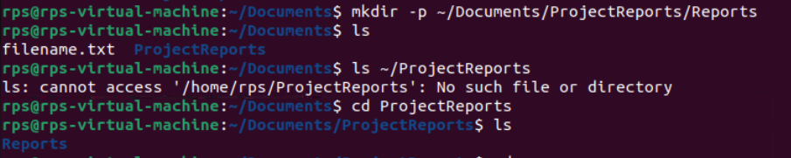

Locate an empty folder you created earlier. Use rmdir to delete it. Confirm its removal with dir / ls.

rmdir ~/Documents/OldEmptyFolder

ls ~/Documents

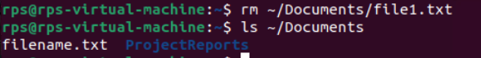

Explore using dir / ls to identify empty folders within a specific directory.

find ~/Documents -type d –empty

